Elementary Lunch Meal



**Five Items**

1. Protein 2. Bread 3. Fruit 4. Vegetable 5. Milk

You may take all five items, but must take at least three items, with one of the three items being a fruit or vegetable to count as a lunch. Entrée’s usually count as two items (Protein, Bread).

**If you do not have a fruit or vegetable it is not a meal and you will be charged ala carte, which can cost more than the full meal price and be less nutritious!**

Choose One Entrée (Protein, Bread)

Choose up to 2 Fruits & 2 Vegetables



Choose One Milk

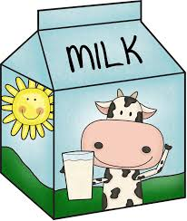

1% White, Skim & Non-Fat Chocolate Milk)